**Project Title: Project Design Phase-I** - **Solution Fit Template Team ID:** PNT2022TMIDxxxxxx

Smart waste management in metropolitan cities

PNT2022TmID26064

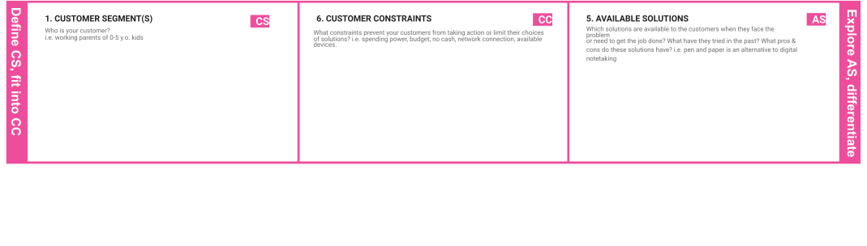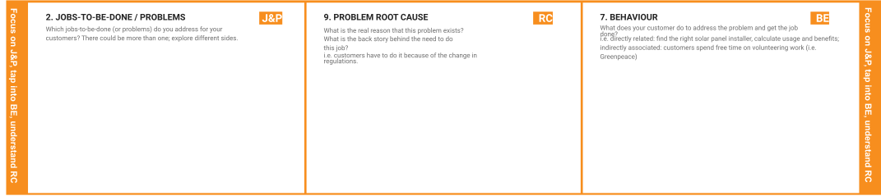

No separation bins are provided. people leave waste in plastic bags beside roads. Some households purchased waste bins but then others used these bins too. People do not know where to put their garbage because there are no fixed waste collection points or times for garbage collection.

* Schools
* Hospitals
* Public
* Municipalities

Smart waste management is characterized by the usage of technology in order to be more efficient when it comes to managing waste. This makes it possible to plan more efficient routes for the trash collectors who empty the bins, but also lowers the chance of any bin being full for over a week.

Identify the pre-incident WMP that best aligns with the specific incident, if applicable. Identify waste management- related policy or implementation issues that require resolution

A reduction in the number of waste collections needed by up to 80%, resulting in less manpower, emissions, fuel use and traffic congestion. A reduction in the number of waste bins needed. Analytics data to manage collection routes and the placement of bins more effectively.

There are significant safety challenges facing the waste/recycling industry. They include chemical exposure combustible dust explosions, machine guarding hazards, and exposure to powerful equipment with moving parts

|  |  |  |  |  |
| --- | --- | --- | --- | --- |
|  | **3. TRIGGERS TR**  What triggers customers to act? i.e. seeing their neighbour installing solar panels, reading about a more efﬁcient solution in the news.  By installing this project we can trigger peoples by seeing their neighbor peoples make the utilization of t echnology more useful and reading about a more efficient solution in the news. | **10. YOUR SOLUTION SL**  If you are working on an existing business, write down your current solution ﬁrst, ﬁll in the canvas, and check how much it ﬁts reality.  If you are working on a new business proposition, then keep it blank until you ﬁll in the canvas and come up with a solution that ﬁts within customer limitations, solves a problem and matches customer behaviour.  You can put that reusable bottle to use, save money and reduce waste. By taking your own water with you, you’ll also reduce your chances of purchasing more expensive beverages on-the-go. This will eliminate the one-time use containers they come in. While most cans and bottles can be recycled, they require a lot of energy to be produced, shipped to the bottling facility and then store for purchase | 1. **CHANNELS of BEHAVIOUR CH**    1. **ONLINE**   What kind of actions do customers take online? Extract online channels from #7   * 1. **OFFLINE**   What kind of actions do customers take ofﬂine? Extract ofﬂine channels from #7 and use them for customer development.  ONLINE: People may provide review and rating for the system.  OFFLINE: People may provide a valuable resource and contribution to the organization |  |
| **4. EMOTIONS: BEFORE / AFTER EM**  How do customers feel when they face a problem or a job and afterwards?  i.e. lost, insecure > conﬁdent, in control - use it in your communication strategy & design.  After the implementation of smart waste management system our environment will be neat and clean. |

|  |  |  |  |  |
| --- | --- | --- | --- | --- |
|  |  |  |  |  |